How to Cross Talk
Cross talk can help your students practice these skills.
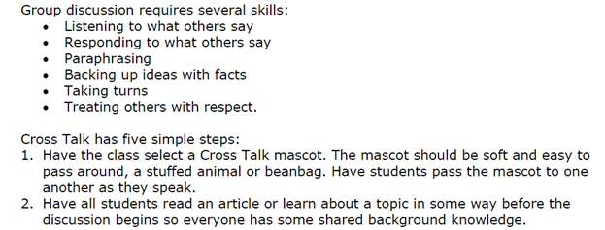
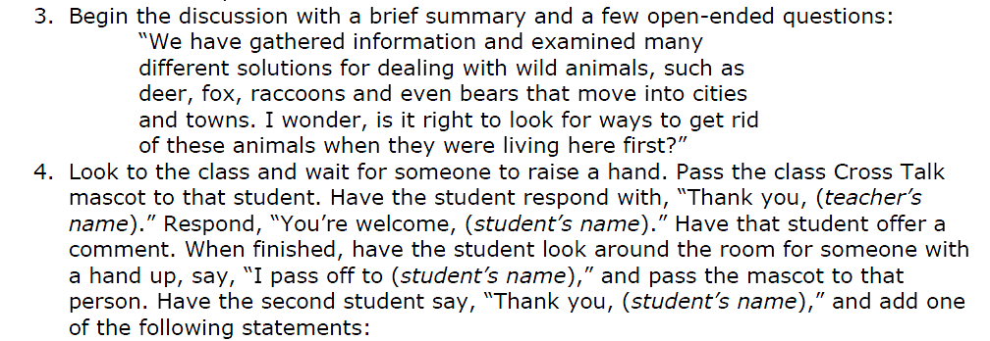
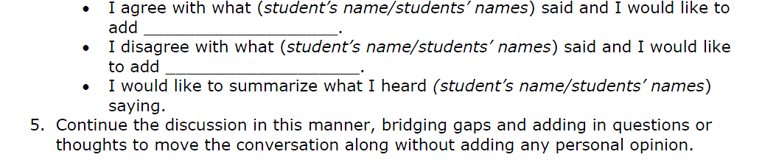

Cross Talk Tips
- For older students choose an object to pass that they will find interesting and not too juvenile. Slinkys and scrunch balls make good passing objects.
- Post the response statements on the wall or SMART Board.
- If a student is hanging back and not participating, you might say, “The conversation is coming to you Sally after two more turns.”
- You might structure the passing of the object so everyone has a turn.
- Keep the activity to about 10 minutes.
- You can use cross talk to discuss class topics or to discuss an issue that has occurred and needs to be discussed by the class.
- Adapt so it meets your style of being.

